SMARTSPOT: AI-POWERED SMART PARKING MANAGEMENT SYSTEM
A Mini Project Report
Submitted in Partial fulfilment of the
Requirements for the award of the Degree of
BACHELOR OF SCIENCE (COMPUTER SCIENCE)
SEM V
By
Sara Laskar
Roll No. 3
Under the esteemed guidance of
Prof. Javed Pathan
Assistant Professor

DEPARTMENT OF COMPUTER SCIENCE
RIZVI COLLEGE OF ARTS, SCIENCE AND COMMERCE
(Affiliated to University of Mumbai)
MUMBAI-400050
MAHARASHTRA
2026-2027

Introduction
With the increasing number of vehicles in urban areas, finding an available parking space has become a common challenge. Drivers often spend valuable time searching for parking, leading to traffic congestion, fuel wastage, and inconvenience. Traditional parking systems do not provide real-time availability or efficient parking management.
SMARTSPOT: AI-Powered Smart Parking Management System is a mobile application designed to simplify parking through intelligent digital solutions. The system allows users to view nearby parking locations, check live parking availability, reserve parking slots, navigate using Google Maps, make online payments, and manage their parking history and profile.
The application also incorporates Artificial Intelligence (AI) to provide smart recommendations such as the best available slot, closest parking area, least crowded parking, and estimated walking time. By offering real-time information and intelligent suggestions, SMARTSPOT aims to make parking faster, more convenient, and more efficient for users.

Problem Statement
Finding an available parking space has become increasingly difficult due to the growing number of vehicles in urban areas. Drivers often waste time searching for parking, resulting in traffic congestion, fuel consumption, and inconvenience. Existing parking systems lack real-time availability, online reservations, and smart parking guidance.
The major problems addressed by the proposed system include:
- Difficulty in finding available parking spaces.
- Time and fuel wasted while searching for parking.
- Lack of online slot reservation.
- Absence of smart parking recommendations.
The proposed SMARTSPOT: AI-Powered Smart Parking Management System addresses these challenges by providing real-time parking updates, slot reservation, navigation, secure payments, and AI-based recommendations for a faster and more efficient parking experience.

System Architecture
The proposed system follows a three-tier architecture consisting of the Presentation Layer, Application Layer, and Database Layer.
Presentation Layer (Frontend)
The frontend is developed using React Native with Expo, providing a responsive and user-friendly mobile interface. It allows users to register and log in, search nearby parking locations, view real-time parking availability, reserve parking slots, make payments, access parking history, manage their profile, and receive AI-based parking recommendations.
Application Layer (Backend)
The backend is built using Node.js and Express.js. It handles user authentication, parking slot management, reservation processing, payment handling, AI recommendation logic, notifications, and communication between the frontend and database through REST APIs.
Database Layer
The application uses MongoDB, a NoSQL database, to store user information, vehicle details, parking locations, slot availability, reservations, payment records, and parking history. MongoDB provides flexible data storage, fast retrieval, and scalability, ensuring efficient system performance.

System Workflow
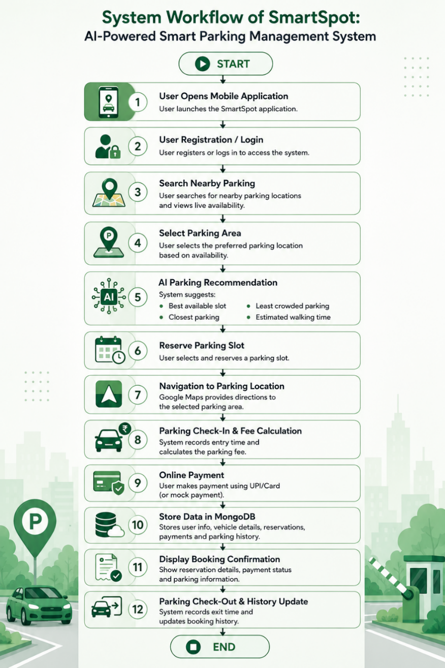

Technologies Used
The application is developed using modern technologies that support real-time data management, secure authentication, and scalable system performance.
Technology | Purpose
React Native | Cross-platform mobile application
Expo | Simplifies app development, testing & deployment
JavaScript | Programming language used for development
Node.js | Backend development
Express.js | REST API development
MongoDB | NoSQL database for storing users, parking slots.
Google Maps API | Displays parking locations and provides navigation

Advantages
- Centralized management of parking locations and reservations.
- Real-time parking slot availability and status updates.
- AI-powered parking recommendations for better slot selection.
- Easy online slot reservation and secure payment management.
- User-friendly mobile interface with Google Maps navigation.
Disadvantages
- Requires an internet connection for real-time parking updates.
- AI recommendations are rule-based and may not always suggest the optimal parking slot.
- Real-time parking availability depends on accurate and timely data updates.
- Users must have a smartphone to access the application features.
- Limited functionality if the backend server or database is unavailable.

Project Report
Current Project Status
The development of the SMARTSPOT: AI-Powered Smart Parking Management System is progressing steadily. The project configuration and backend implementation have been completed successfully. At present, the frontend is under development, while the research phase and AI module integration are being carried out simultaneously. Once these components are completed, the application will undergo rigorous testing to verify its functionality, performance, and reliability before its final deployment.
Progress Summary
Task | Status
Overall Project | 75% Completed
Research & Planning | 80% Completed
Project Setup | Completed
Jira Project Management | In Progress
Frontend Development | In Progress
Backend Development | 90% Completed & Tested
AI Integration | 50% Completed

Completed Work
- Project requirement analysis and research (almost completed).
- Project setup and environment configuration.
- Backend development with REST APIs (almost completed and tested).
- Database integration and API testing.
- Responsive frontend authentication screens and Home page.
Remaining Work
- Parking slot availability and reservation module.
- AI-based parking recommendation integration.
- Google Maps navigation integration.
- Payment module implementation.
- Completion of research documentation.
- End-to-end testing, bug fixing, and final deployment.
Conclusion
The SMARTSPOT: AI-Powered Smart Parking Management System provides a smart and efficient solution for parking management by offering real-time parking availability, slot reservation, secure payments, navigation, and AI-based recommendations. It aims to reduce parking time, improve user convenience, and optimize parking space utilization.

